COM210 Project Creative Brief
PROJECT 1: FLIER

Date: 10/22
Name: Inan Harsh

PROJECT BACKGROUND
What is the project? What are we creating and why? What are we trying to achieve with this project? What is the core message that should be communicated?

This project is for Circus Club’s Fire Friday, a place for fire spinners and breathers to get together for a community night of safe (as possible) fire spinning. We are trying to create awareness/advertising for community (and others) spinners to motivate and encourage showing up to the gathering. The core message is information about time, place, and why spinners should show up.

TARGET AUDIENCE & JUSTIFICATION:
Who is your target audience? [You can’t say everyone!] What do we know about them that can help us reach them? What is your plan to appeal to this audience?
Target audience is all flow artists who want to get involved in fire Friday nights to show up and spin fire. We know they are artists, want to spin fire, and need some motivation and appeal to show up to these community events.

INSPIRE US!
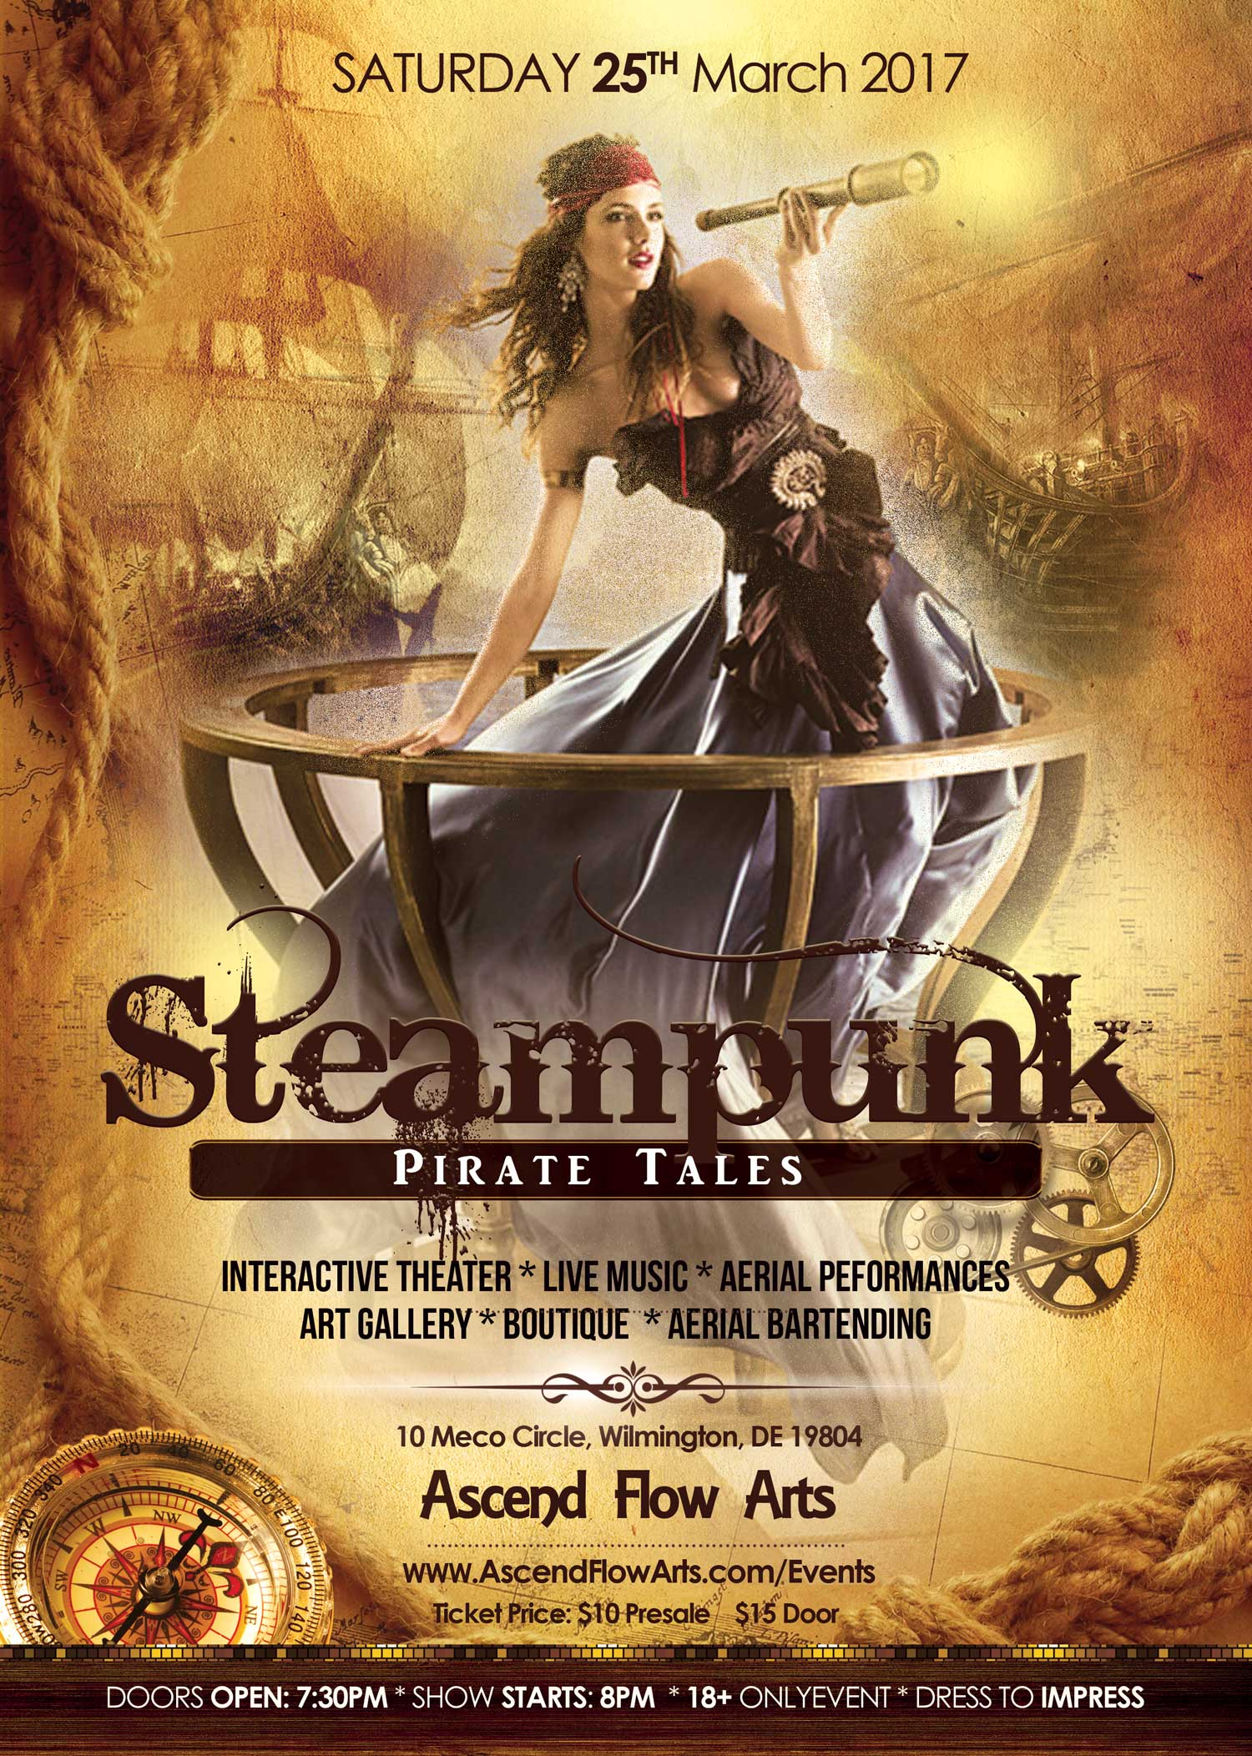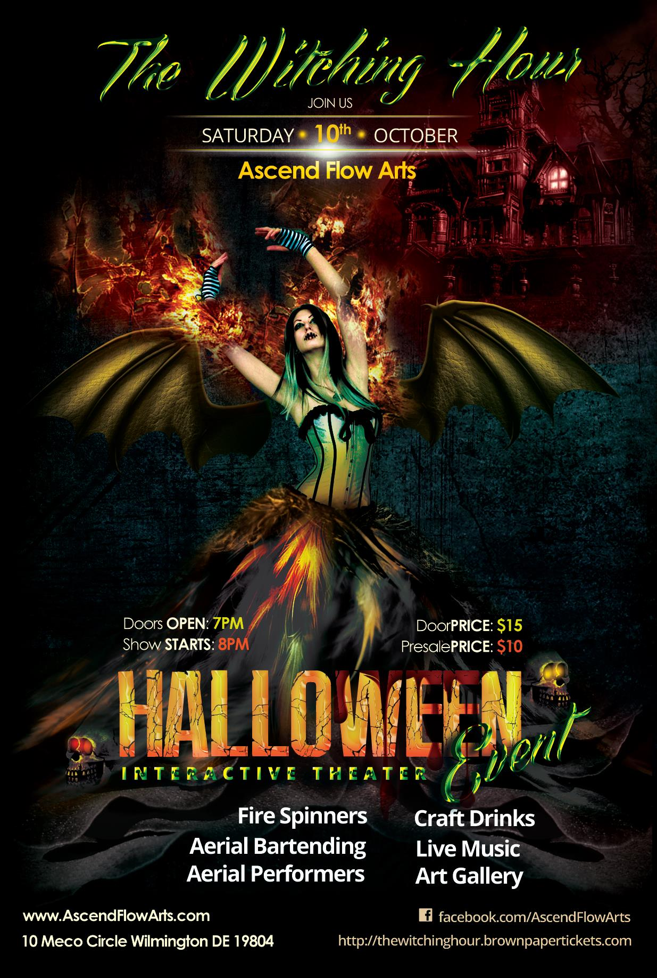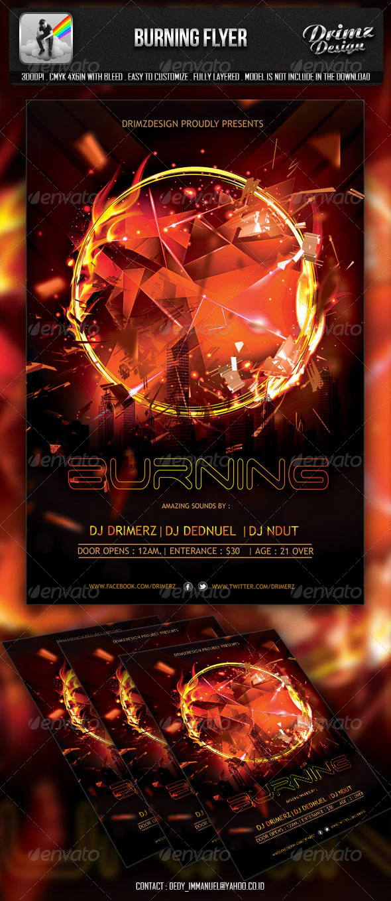

SKETCH
